Capacity Challenges on the California High-Speed Rail Shared Corridors: How Local Decisions Have Statewide Impacts
Sam Levy and Joseph M. Sussman
Department of Civil Engineering, Massachusetts Institute of Technology, Cambridge, MA

In 2012, as a cost-control measure and in response to local opposition in the San Francisco Bay Area, the California High-Speed Rail Authority (CHSRA) adopted a "blended system" at the north and south bookends of the planned first phase of its high-speed rail line. In this blended operation, the high-speed rail line will share track and other infrastructure with commuter rail, intercity rail, and freight on the 50-mile Peninsula Corridor in Northern California and on 50 miles of right-of-way between Burbank, Los Angeles, and Anaheim in Southern California.
In Northern California, the Peninsula Corridor Joint Powers Board’s (PCJPB) Caltrain commuter rail service between San Francisco and San Jose is experiencing record levels of ridership. Ridership will be further stimulated by the electrification of the line and its extension into San Francisco’s central business district. With the California High-Speed Rail Authority competing spatially and temporally with Caltrain for access to high-revenue and high-cost infrastructure, we review different strategies for coordination and integration between the two agencies.
In Southern California, the final form of the blended system is more nebulous than its northern counterpart. For the first few years of high-speed rail service, the Metrolink service operated by the Southern California Regional Rail Authority (SCRRA) is expected to complement the high-speed rail system. However, since Metrolink operates on congested rail infrastructure, some of it owned by capacity-conscious freight railroads, there will exist the challenge of providing quality service and transfer opportunities for time-sensitive high-speed rail customers.
The change to a blended system was a dramatic change of direction for the CHSRA; as a result, a new paradigm is needed for implementation of the system over the next 15 years. The decisions made on the local blended corridor level will affect both the financial viability of the overall project and the quality of service experienced by customers across the entire California rail system.

Introduction
California’s Proposition 1A, passed by voters in 2008, authorized $9.95 billion from a state bonds issue that provide partial funding for construction of an HSR line capable of transporting passengers between Los Angeles and San Francisco in no more than 160 minutes with trains capable of running at least 200 miles per hour. Since 2008, the CHSRA has won funding (totaling approximately $15 billion) from President Obama’s American Recovery and Reinvestment Act and the FRA’s High Speed Intercity Passenger Rail (HSIPR) program, as well as from California’s cap-and-trade carbon emissions reduction program. With the remaining funding expected to come from private investment, the $68 billion Phase 1 of the system between San Francisco, Merced, Los Angeles, and Anaheim (with future phases to Sacramento and San Diego) is planned for completion in 2028 (See Figure 1).
The CHSRA’s shift to a “blended system” from dedicated line reflects the reality that the costs and challenges associated with constructing new, dedicated rail infrastructure are enormous, especially in urban areas. Shared rail corridors represent the possibility of more efficient use, that is, higher utilization, of precious rail infrastructure. Multiple railroads can share the burden of track maintenance and traffic control, both of which require high fixed costs. Sharing track, when done properly, is an attractive option for both passenger rail agencies and freight railroads and increasingly common in the United States. However, sharing track comes with challenges for all participating railroad operators as well.
Figure 1. Map of current California HSR implementation plan. Blended service areas are shown in dark blue.
Source: CHSRA
Sharing track requires coordination and more often than not, it is among non-homogenous rail traffic. In California, rail traffic is non-homogenous in both operating characteristics such as stopping patterns and running speed and in physical characteristics such as necessary lateral and vertical clearances and station platform and vehicle door heights.
The overarching goal of this research is to offer recommendations on how California’s rail capacity might be managed better going forward and to develop a methodology to approach design decisions that affect capacity. As travel patterns and freight demands move across rail corridors with different owners, capacity planning becomes increasingly important.

Northern California Blended Service
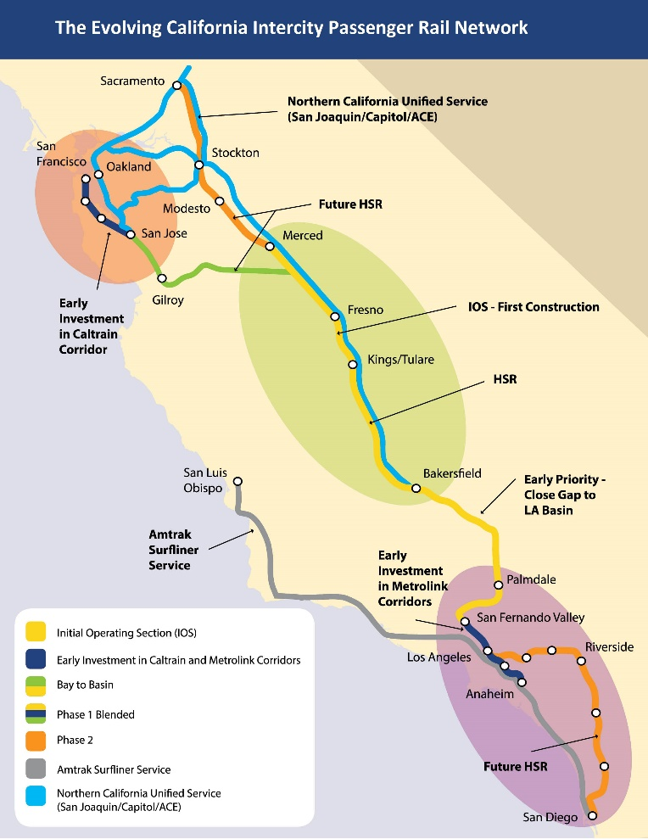
The Peninsula Corridor Joint Powers Board (PCJPB) made up of the three counties served on the 87-mile network, owns the northernmost 51-miles of track between San Francisco 4th and King Station and San Jose Station and operates commuter service between the cities, branded as Caltrain. Union Pacific uses the corridor for freight service in and out of San Francisco and maintains perpetual trackage rights. The PCJPB and its relationship with Union Pacific, the CHSRA, and the private HSR operator on the corridor is already and will continue to be instrumental in the ultimate form of high-speed rail in California.
Caltrain is enjoying huge ridership growth due, in part, to the thriving economic conditions in Silicon Valley and San Francisco and the millennial generations’ desire to leave the car at home or not own a car at all and be productive on the daily commute. The “Baby Bullet” express service has reduced travel times, but has also drawn many commuters to bring their bikes on-board—Caltrain sees more bicyclists on-board than any other transit agency in the nation.
Caltrain has two major upcoming capital projects that will spark additional ridership growth. First, an electrification of the corridor will allow for more local services--making the train a more convenient option. Second, the extension of Caltrain to the Transbay Transit Center will bring Caltrain riders much closer, and via a one-seat ride, to San Francisco’s job center.
The Transbay Transit Center, which will be owned by the third-party Transbay Joint Powers Authority (TJPA), will be located near more jobs and residents than any other existing Caltrain station. For a private, for profit high-speed operator it will serve as a revenue generator in part because San Francisco is best equipped to accommodate the car-less HSR traveler. The two operators will compete both spatially for the six-track terminal and temporally during the rush hour peaks (See Figure 2). Currently, the plan is to have two dedicated Caltrain tracks and four dedicated HSR tracks, but the Transbay Joint Powers Authority is urging the two agencies to consider adopting standard vehicle height to allow for platform sharing. Without platform sharing and high levels of commuter-HSR integration, the local constraints will affect service quality not just on the Peninsula, but across the state.
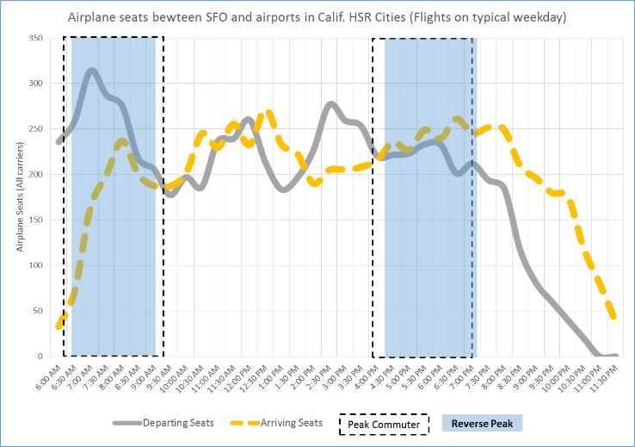
Figure 2. Caltrain peak periods (represented by blue and dashed boxes overlap temporally with air seats out of San Francisco (a proxy for HSR travel)
Source: Caltrain ridership, SF International Airport schedule data
Using this knowledge that the northernmost 1.3 miles of the high-speed rail line will be a vertically separated structure, we apply the vertically-separated train operator model developed by Levy, Sussman, Pena-Alcaraz, and Prodan in TRB 15-1697. This revealed that it will be difficult for the high-speed rail operator and Caltrain to compete on a level playing field for access to the Transbay Transit Center due to the fiscal strength of the high-speed rail operator, not to mention the state-wide political constituency behind HSR service.

Southern California Blended Service
As in Northern California, high-speed rail operations will be blended with commuter rail operations. However, in Southern California, there are more operators, sections of freight-owned right-of-way, and no plans to electrify non-HSR operations. Blended service planning is nascent in Southern California, even more so than the Northern California system.
Los Angeles Union Station to Southern California is analogous to the Transbay Transit Center in the Bay Area. It is better connected to Los Angeles’ population centers and will continue to serve as a regional transportation hub regardless of the ultimate success of high-speed rail. With 14 tracks currently used by three rail operators (Metrolink, Amtrak, and Amtrak California’s Pacific Surfliner), it will be an important hub for the high-speed rail operator and its future warrants careful consideration.
One of the key rail capital projects in Southern California are the Union Station run-through tracks, known as the Southern California Regional Interconnector Project (SCRIP) Currently, all trains arriving and departing from and to San Diego to the south, San Luis Obispo and Santa Barbara to the north, and San Bernardino County to the east all use the same approach tracks to the north of the “stub-end” terminal. The four run-through tracks (some of which will be used by high-speed rail trains) will add a high degree of flexibility for express services and inter- and intra-agency transfers and coordination. Construction is scheduled to be completed in late 2019 or early 2020 (ibid).
At the time of writing, this blended system runs approximately 50 miles from Burbank in the San Fernando Valley through Los Angeles Union Station and on through to Anaheim’s newly-built Anaheim Regional Transportation Intermodal Center (ARTIC). Currently, electrification in Southern California is solely for high-speed rail. Metrolink and Amtrak California have no plans to electrify their systems. From 2022 to 2028, riders would transfer from high-speed rail at Burbank to slower, diesel powered trains for the ride southward to Los Angeles and Anaheim. When the CHSRA completes Phase 1 in 2028, HSR trains would share tracks, but not stations, with Metrolink and the Pacific Surfliner south through Los Angeles and onwards towards ARTIC. Metrolink and the Surfliner, though, would continue conventional rail operation, though possibly at higher speeds than today.
Unlike Caltrain in Northern California, Metrolink and Amtrak California also have no plans to change the specifications in terms of door height or floor height on their operating train sets. This means that high-speed rail will have to use separate platforms even if tracks are shared in between stations. This could limit the capacity and benefit of Los Angeles Union Station because the run-through tracks need to be assigned specifically to high-speed rail or conventional rail.

Conclusion
The blended system of shared corridors will put high demands on the existing infrastructure. Commuter rail or freight delays can propagate to the HSR system. As the ratio of service volume to capacity tends towards 1, the system loses stability and on-time performance suffers. With degraded on-time performance and uncertainty regarding arrival times, schedule padding becomes necessary and makes rail as a mode less attractive to time-sensitive consumers.
California’s Rail “Wish-List”
Level Boarding and Interoperability
Ability to modify service levels
Xpress West integration with California HSR
Integrated Southern California network
High-frequency, uniform-headway HSR and commuter rail
Satisfy 2008 bond measure requirements
Minimize costs and build the network quickly

Figure 3: Inferred “wish-list” of an integrated, blended CHSRA network
The blended system dictates that the CHSRA will operate on a multi-owner network, in many ways like Amtrak does today. Instead of having sole control of its infrastructure, the CHSRA will have to work with the TJPA, PCJPB, SCRRA, and BNSF Railway to ensure smooth operation. As a result, the CHSRA will face many of the issues Amtrak faces today regarding train priority. The ability for the CHSRA to operate in a reliable fashion will depend on the priority rules that the CHSRA can negotiate with its host railroads on the blended corridors. Optimizing locally constrains the overall system optimal solution; and as agencies make decisions regarding vehicle fleets and track investments, we can see that the local optimizing has already begun. Decisions made on the Peninsula Corridor can create capacity bottlenecks affecting HSR trains inter-regionally. And since these blended issues are being addressed presently on the Peninsula Corridor with the concurrent electrification of Caltrain, a precedent is being set for their southern neighbors. The Peninsula Corridor, therefore, is an important proving ground for whether or not blended operations can work.
Integrated operations have a potential to bring HSR a revenue source; like regional airlines feed into international hubs, so too can commuter rail services feed into interregional high-speed rail services. To that end, service planning should drive infrastructure decisions; in an era where infrastructure such as new HSR stations or electrification are expensive and the public is leery of megaprojects, California can set an example with a well-conceived (i.e. well service- planned), integrated rail system.

References
California High-Speed Rail 2014 Business Plan. California High-Speed Rail
"Caltrain Modernization Program" Peninsula Corridor Joint Powers Board. May 2015
Caltrans. 2013 California State Rail Plan. 2013 Leg. Sacramento: California State Transportation Agency, 2013. California Department of Transportation.
The authors would thank the National University Rail (NURail) Center, a US DOT-OST Tier 1 University Transportation Center for sponsoring this study.

